**Họ và tên:...................................... Ngày 29/4/2020**

**Lớp: 3/ ......**

**FAMILY AND FRIENDS SPECIAL EDITION 3**

**UNIT 10: YOU ARE SLEEPING.**

I/ Write these words. ( viết những từ này )

|  |
| --- |
|  |
|  |
|  |
|  |
|  |
|  |
|  |
|  |

II/ look at the pictures, look at the letters and write the words.

( nhìn vào những bức tranh, nhìn vào những ký tự và viết những từ )

|  |  |  |
| --- | --- | --- |
| Những yếu tố tạo nên một đám cưới hoàn hảo. | _ _ _ _ _ _ _ _ | G W I E D N D |
|  | _ _ _ _ | N D A B |
| Paper Wedding Invitation Card, Rs 15 /piece, Multivision | ID ... | _ _ _ _ _ _ _ _ _ _ | TNVIAIOTNI |
|  | _ _ _ _ _ | I B E R D |
|  | _ _ _ _ _ _ | S U G T E S |

III/ Do the crossword base on the clues below ( làm trò chơi ô chữ dựa vào những gợi ý bên dưới )

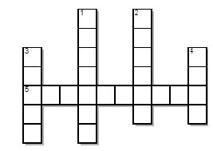

1. The party where a man and a woman become the two important people. After that they will be husband and wife.
2. People who come to a party.
3. One of the two important person in their wedding.
4. A small group of musicians who play popular music together, often with a singer of singers.
5. A card or piece of paper that you use to invite someone to do something.